



**VPL Usage Scenarios**

Contents

Connecting Cables 3

Dish Configuration 4

Program Remote 6

Program Search, Playback and Record 8

To get the most out of VPL agents should familiarize themselves with the interface and then step through instructor led scenarios. There are endless combinations when VPL can be used as a quick reference (i.e., Does a receiver client have a component connection output?), a detailed menu walk through (i.e., What are steps for the receiver Network Setup) or just to discover something new about our receivers (i.e., can you download all the seasons of a show?).

The scenarios in this module focus on the most common calls: connections, setup, programing, and customer education.

* Connections: Back Panel Connections
* Setup: Dish Configuration
* Programming: Program Remote
* Customer Education: Program Search, Recording and Playback

# Connecting Cables

Customers sometimes get confused where to connect the cable to get video. The best way is to orient the customer to the connections on the back of the receiver. After then it’s just plug and play.

**Call Scenario:** Customer just received a replacement receiver and needs to connect it to her HDTV.

Log in to VPL:

1. Select a VPL receiver (See screenshot: *VPL Receiver Cable Connections*)
2. Click “Back” button to view back panel of receiver
3. Use “+” to zoom in to read the labels and ID the connection types
4. Make note of all the connections on back, look for the HDMI connection
5. What type of cable would you need to use? (Answer: HDMI Cable)
6. When you have completed the exercise:
   * “X” out of the receiver

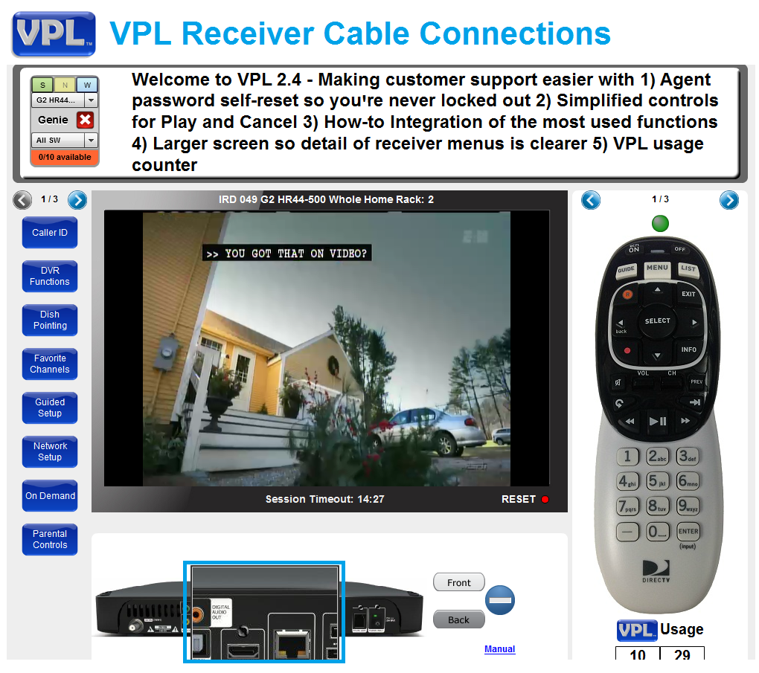

# Dish Configuration

The most effective way to complete the guided setup or a dish configuration is to know that the receiver will detect the available dish types. You only have to select the correct dish. For most installs, set the receiver to “03: Slimline-3”. With any dish type error such as: OSD 920, Error 82/83, Channel Unavailable, To Be Announced, just follow WFE scripting to resolve.

**Call Scenario:** Customer just received a replace receiver, need set up dish. Note: when a customer first connect a new receiver they will be asked to select language. After that the steps of the “Guided Setup” are essentially the same as the “Dish Configuration” or “Repeat Satellite Setup”. If more guidance is needed select “Guided Setup” in the How-to.

Log in to VPL:

1. Select a VPL receiver (See Screenshot: *Satellite Dish Setup*).
2. Arrow to the “Repeat Satellite Setup” How-to Function
3. Read instruction in Direction Pane.
4. Follow the receiver onscreen instructions (See Screenshot: *Satellite Dish Setup Menu*).
5. When you have select the dish type:
   * Select “Continue” on the receiver menu
   * Select “Set Remote Up Later”.
   * And let the advance program guide reload.
   * When 100% complete click continue “Watch DIRECTV”
6. When you have completed the exercise:
   * Select “Done” on the receiver menu
   * And “X” out of the receiver

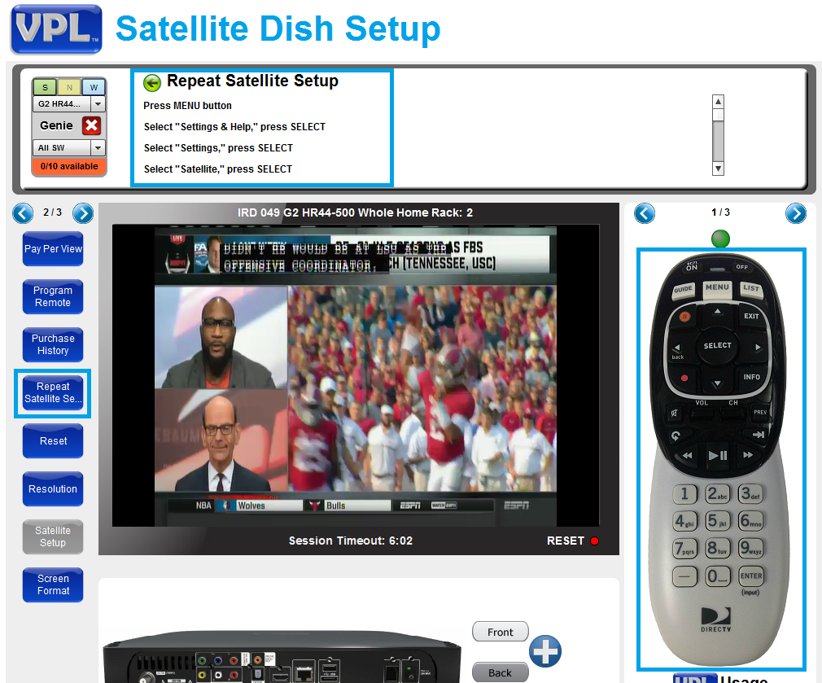

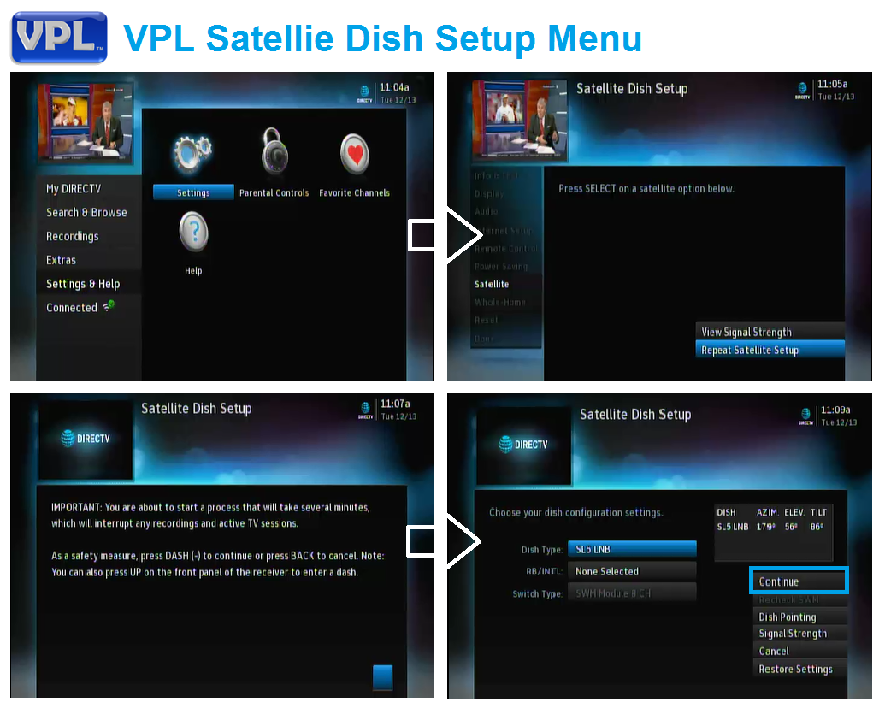

# Program Remote

The most effective way to program a remote control is to use the receiver on screen information. A customer can see the information and read it. You won’t need to repeat information and will stay in sync with the customer.

**Call Scenario:** A customer just received a replacement receiver and/or purchased a new TV. Customer wants the volume to work with TV. Doesn’t want to have to use two remotes. Codes are listed from most current to oldest. Note: with Genie receiver they will auto program via RF4CE just by pointing the remote. Again, just have customer follow direction on the screen.

Log in to VPL:

1. Select a VPL receiver (See Screenshot: *Program Remote Setup*)
2. Arrow to the “Program Remote” How-to Function
3. Read instruction in Direction Pane
4. Follow the receiver onscreen instructions (See Screenshot: *Program Remote Menu*)
5. When you have completed the exercise:
   * Select “Done” on the receiver menu
   * And “X” out of the receiver

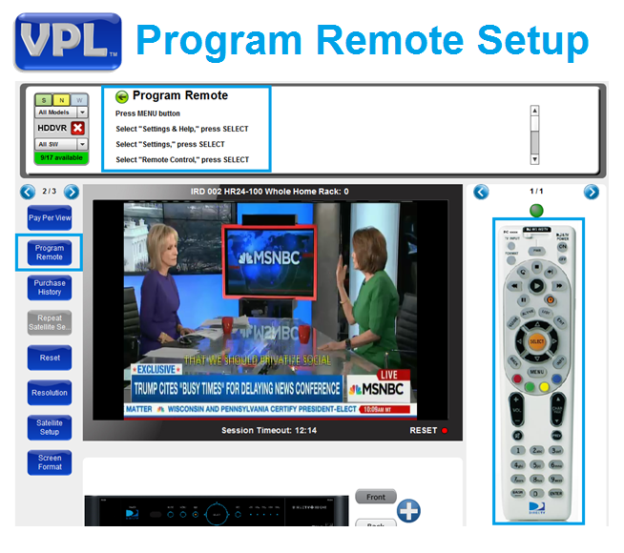

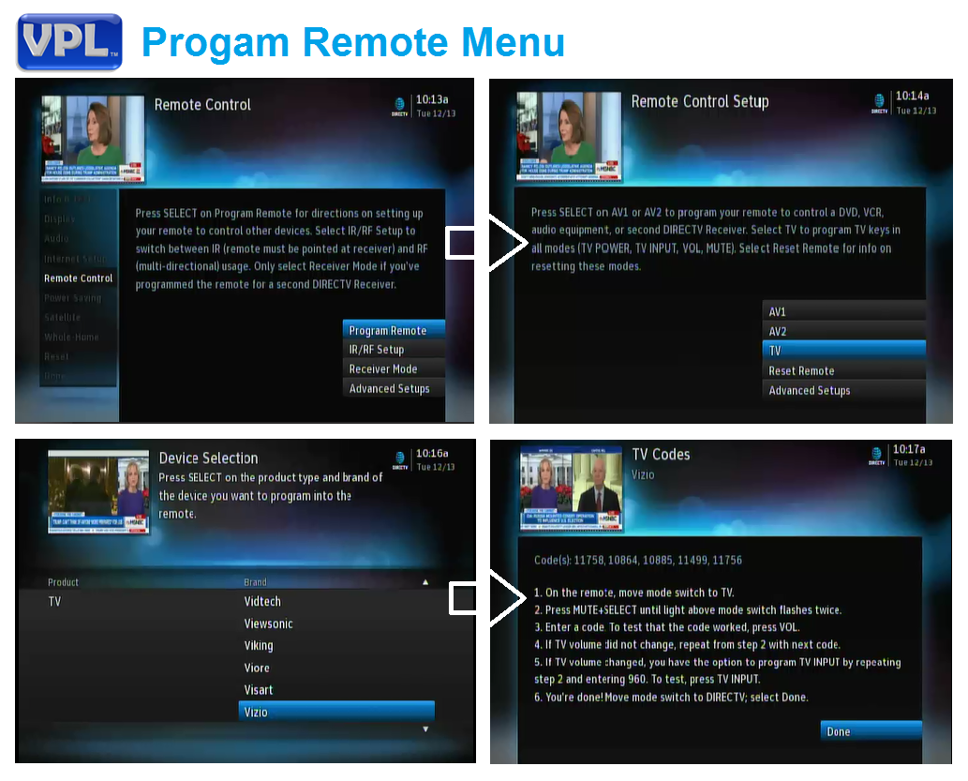

# Program Search, Playback and Record

The most effective way to find a program and record it is to use Smart Search. Type in the keyword and the program guide will look through all available shows for up to 14 days. Many shows are available on demand either via satellite on broadband.

**Call Scenario:** A customer just got her DIRECTV installed; she is very excited. On NPR she heard a review about the Showtime series “The Affair”. It’s in its 3rd season and the reviewer David Bianculli said: “(It) has to be added to my weekly must-watch list.” Show the customer how to find it and add it to their “must-watch” list: Record Series and Watch Now.

1. Select a VPL receiver (Note: Will need an HD DVR)
2. Press Menu and select “Search and Browse”
3. Type in the name of the show until it appears search results: “AFF”
4. Select the show “The Affair” and pick the season “Season 1” (See screenshot: VPL Program Search & Record”
5. Record Series and view in recording listing
6. Or Click “Watch Now” (See screenshot: *VPL Program Search, Playback and Record*)

- Customer can start watching as soon as it starts downloading

- If download is slow customer may get a buffering message > that is okay. Just wait a minute or watch later to resume

- When you have completed the exercise:

* + And “X” out of the receiver

